
AI – Powered Personalized Learning System
MINI PROJECT REPORT
Submitted By
S.A ILYAS AHAMED – 24623148
M.BHUVAN SAI - 24623138
R.SRIRAM - 24623128
VELS INSTITUTE OF SCIENCE, TECHNOLOGY & ADVANCED STUDIES
(VISTAS)
in Partial fulfillment of the requirements for the award of the degree of
BACHELOR OF TECHNOLOGY CSE –
ARTIFICIAL INTELLIGENCE


Submitted to the
SCHOOL OF ENGINEERING
DEPARTMENT OF ARTIFICIAL INTELLIGENCE & MACHINE LEARNING
VELS INSTITUTE OF SCIENCE, TECHNOLOGY AND ADVANCED STUDIES (VISTAS)
CHENNAI – 600 117
OCTOBER 2026
BONAFIDE CERTIFICATE

Certified that this project report entitled “AI-Powered Personalized Learning System” is the bonafide work of S. A. Ilyas Ahamed (24623148), M. Bhuvan Sai (24623138), and R. Sriram (24623128), carried out under the supervision of Ms S.M Sowmiya, Assistant Professor, AI & ML, Vels Institute of Science, Technology & Advanced Studies (VISTAS). It is further certified that, to the best of my knowledge, the work reported herein does not form part of any other project report or dissertation on the basis of which a degree or award was conferred on any candidate on an earlier occasion, either at this or any other institution.

SIGNATURE OF THE HOD SIGNATURE OF THE SUPERVIOR
Dr. K. Ulaga Priya M.E., (Ph.D) MS. S.M Sowmiya M.E.,(Ph.D)
Associate Professor & Head Assistant Professor
Of Department AI&ML Department of AI&ML
School of Engineering School of Engineering
VISTAS VISTAS
Chennai Chennai

Submitted for the Project Work and Viva - Voce examination held on……………
at Vels Institute of Science, Technology and Advanced Studies (VISTAS), Chennai – 600117.

INTERNAL EXAMINER EXTERNAL EXAMINER

ACKNOWLEDGEMENT

It is a great pleasure and privilege to express my sincere gratitude to all those who have supported and encouraged me in the successful completion of this project. I would like to extend my heartfelt thanks to our Founder and Chairman, Shri Dr. Ishari K. Ganesh, for providing the necessary infrastructure and facilities to carry out this work. I am sincerely grateful to our Head of the Department, Dr. K. Ulaga Priya, for her continuous support, valuable guidance, and encouragement throughout the project. I would also like to express my sincere thanks to my Class Teacher for the constant support, encouragement, and guidance provided throughout this academic journey. I extend my deepest gratitude to my Internal Guide, Ms S.M Sowmiya, for her patience, invaluable advice, and guidance from the initial conceptualization to the completion of this project. I would also like to thank the faculty members, laboratory staff, and non-teaching staff of the Department of Computer Science and Engineering for their assistance and support. Last but not least, I extend my heartfelt thanks to my parents and friends for their constant encouragement, understanding, and motivation, which inspired me to overcome challenges and complete this project successfully.

S.A ILYAS AHAMED - 24623148
M.BHUVAN SAI - 24623138
R.SRIRAM - 24623128

CHAPTER NO. | TABLE OF CONTENT | PAGE NO.
 | ABSTRACT | i
 | LIST OF FIGURES | ii
1 | INTRODUCTION
1.1 | Overview of the Project | 1
1.2 | Scope and objective | 4
2 | LITERATURE REVIEW
2.1 | Literature Overview | 10
2.2 | Literature Survey | 11
3 | SYSTEM DESIGN
3.1 | Existing System | 13
3.2 | Proposed System | 14
3.3 | System Architecture | 16
3.4 | Hardware Requirements | 19
3.5 | Software Requirements | 20

FIGURE NO. | TITLE | PAGE NO.
 | IMPLEMENTATION
4.1 | Methodology | 24
4.2 | System Implementation | 28
4.2.1 | Document Upload, Text Extraction and Preprocessing
4.2.2 | Text Chunking, Embedding Generation and Vector Storage
4.2.3 | Retrieval-Augmented Generation and AI-Based Question Answering
4.2.4 | User Interface, Chat and Subject Management
4.2.5 | Diagnostic Assessment and Student Performance Analysis
5 | CONCLUSION & FUTURE WORK
5.1 | Conclusion | 31
5.2 | Future Work | 34
5.3 | Source Code | 42
5.4 | Sample Input & Output | 45
 | REFERENCES | 47
 | CERTIFICATION | 48

ABSTRACT
The AI-Powered Personalized Learning System is designed to provide students with a personalized and context-aware learning experience using Artificial Intelligence (AI) and Retrieval-Augmented Generation (RAG). The system processes educational materials in formats such as PDF, DOCX, PPTX, and images using text extraction and Optical Character Recognition (OCR). The extracted content is divided into smaller chunks, converted into semantic embeddings, and stored in a vector database for efficient retrieval. When students ask questions, relevant information is retrieved and provided to a locally deployed Large Language Model (LLM) to generate context-based answers. The system also incorporates test and grade analysis to identify students’ strengths and weaknesses across topics, supporting targeted learning. By combining study materials with performance analysis, the proposed system aims to reduce reliance on generic AI responses and deliver a more personalized and effective learning experience.

Keywords: Artificial Intelligence, Retrieval-Augmented Generation, Large Language Models, Optical Character Recognition, Semantic Embeddings, Personalized Learning.

FIGURE NO. | TITLE
Figure 1 | Proposed System Architecture of AI Study Assistant
Figure 2 | Workflow of the proposed AI study assistant
Figure 3 | Retrieval-Augmented Generation (RAG) Pipeline
Figure 4 | Main dashboard user interface
Figure 5 | Subject Management interface
Figure 6 | Document Upload & Processing Interface
Figure 7 | AI Chat interface for answering student queries
Figure 8 | Diagnostic Assessment Interface
Figure 9 | Student performance analysis & weak-topic identification
Figure 10 | Sample output of AI-Based Question Answering

CHAPTER 1. INTRODUCTION
  - OVERVIEW OF THE PROJECT

Introduction
Artificial Intelligence (AI) is transforming education by making learning more accessible and personalised. The AI-Powered Personalized Learning System combines Retrieval-Augmented Generation (RAG), Large Language Models (LLMs), and document processing to help students learn from their own study materials. The system retrieves relevant information from uploaded documents to answer questions and aims to support students through diagnostic assessments and performance analysis.
Problem Statement
Students often spend considerable time searching through academic materials and may struggle to identify their weak topics. Generic AI tools may also provide answers that are not aligned with their syllabus or study resources. Therefore, a system is needed to provide context-based answers from uploaded materials and support students in identifying areas that require improvement.

Objectives of the Project
The main objectives of this project are:
- To develop an AI-based personalised learning platform.
- To process educational documents in supported formats.
- To implement RAG for context-based question answering.
- To integrate a Large Language Model for generating responses.
- To support diagnostic assessments and student performance analysis.
- To help students identify weak topics and focus on targeted revision.

Scope of the Project
The project focuses on providing AI-based academic assistance through:

- Uploading and organising educational materials.
- Extracting and processing text from supported documents.
- Retrieving relevant information using semantic embeddings and a vector database.
- Generating answers using a language model.
- Analysing assessment results to identify areas for improvement.

System Overview
The system processes uploaded study materials and uses a RAG pipeline to answer student queries. Extracted text is divided into smaller chunks, converted into embeddings, and stored in a vector database. When a question is submitted, relevant content is retrieved and passed to the language model to generate a context-based response.
System Workflow
Document Upload → Text Extraction → Chunking and Embedding → Vector Database → Information Retrieval → Answer Generation → Performance Analysis
Advantages of the System
- Provides answers based on uploaded study materials.
- Reduces the time spent searching through documents.
- Supports semantic search for relevant information.
- Organises learning resources by subject.
- Encourages focused revision through performance analysis.
- Offers the potential for local AI processing.

Applications of the Project
- Examination preparation and revision.
- Self-paced learning.
- Academic doubt clarification.
- Educational document management.
- Diagnostic testing and performance analysis.
- Supplementary learning support for college students.

Expected Outcomes
At the end of this project, the expected outcomes include:
- Provide context-based answers to academic questions.
- Simplify access to uploaded study materials.
- Demonstrate the application of RAG in education.
- Support the identification of weak topics through assessment analysis.
- Establish a foundation for Personalized learning assistance.

Future Enhancements
- Support for additional document formats and complex visual content.
- Automated quiz generation from uploaded materials.
- Improved Personalized learning recommendations.
- Multilingual question answering.
- Performance dashboards with topic-wise progress tracking.
- Improved retrieval accuracy and answer verification.

SCOPE AND OBJECTIVE
Purpose of the Study
The purpose of this project is to develop an AI-powered learning platform that helps students understand academic concepts using their own study materials. By integrating Retrieval-Augmented Generation (RAG), Large Language Models (LLMs), and student performance analysis, the system aims to provide relevant answers, simplify access to educational resources, and support targeted learning.
General Objective
To design and develop an AI-powered personalised learning system that uses uploaded educational materials and intelligent information retrieval to provide context-based answers and support students in improving their academic performance.
Specific Objectives
The specific objectives required to achieve this goal include:
- To develop a platform for uploading and managing educational materials.
- To extract, preprocess, and organise content from supported document formats.
- To implement semantic embeddings and vector-based retrieval.
- To integrate a language model for context-based question answering.
- To support diagnostic assessments and identify topics requiring improvement.
- To analyse student performance and encourage targeted revision.
Scope of the Project
Functional Scope
- Uploading and organising study materials by subject.
- Extracting text from supported documents.
- Retrieving relevant information using semantic search.
- Generating answers using a language model.
- Supporting diagnostic assessments and performance analysis, where implemented.

Technical Scope

  - Python-based backend development.
  - Retrieval-Augmented Generation using LangChain.
  - Local language model integration using Ollama.
  - Text embeddings using suitable embedding models.
  - Vector storage and retrieval using ChromaDB.
  - Document processing and Optical Character Recognition (OCR), where supported.

Application Scope
- University and college students.
- Examination preparation and revision.
- Self-paced learning and concept clarification.
- Managing academic documents.
- Identifying learning gaps through assessment analysis.

Importance of the Project

The project is important because it addresses common difficulties in accessing academic information and identifying learning gaps. It combines students’ own educational resources with AI-based question answering, helping them locate relevant information more efficiently. Its assessment and performance-analysis components also aim to encourage more focused and personalised learning.
System Functionality Overview
The system performs the following key operations:

- Document Upload: Students upload their educational materials.
- Text Extraction: The system extracts textual content from supported files.
- Preprocessing: The extracted text is cleaned and divided into smaller chunks.
- Embedding Generation: The chunks are converted into semantic embeddings.
- Vector Storage: The embeddings are stored in a vector database.
- Information Retrieval: Relevant chunks are retrieved when a student asks a question.
- Answer Generation: The retrieved content is supplied to the language model to generate a response.
- Performance Analysis: Assessment results may be analysed to identify topics requiring further study.

Methodology for Achieving Objectives

The project follows a modular development approach, divided into the following stages:

- Requirement Analysis: Identify student learning needs and system requirements.
- System Design: Design the architecture and define the interaction between components.
- Document Processing: Implement text extraction, preprocessing, and chunking.
- RAG Development: Generate embeddings, store them in ChromaDB, and implement semantic retrieval.
- LLM Integration: Connect the retrieval pipeline to a language model through Ollama.
- Interface Development: Develop an interface for document management and question answering.
- Testing and Evaluation: Test the implemented components and assess their functionality and output quality.

Hardware and Software Requirements:

Hardware Requirements
- Processor: Intel Core i5 or higher (or equivalent AMD)
- RAM: 8 GB or higher
- Storage: Sufficient free space for models, documents, and vector data
- GPU (Optional): a compatible GPU may improve model inference speed
Software Requirements
- Frontend: HTML, CSS, JavaScript
- Backend: Python
- Frameworks: LangChain
- Libraries: Hugging Face Transformers, ChromaDB, PyPDFLoader, EasyOCR
- Language Model: Ollama
- Embedding Model: Hugging Face
- Database: ChromaDB
- Development Enviroment: Visual Studio Code (Or any equivalent)

Benefits of the Proposed System
- Provides context-based academic assistance.
- Reduces the effort required to search through lengthy documents.
- Supports semantic retrieval of relevant information.
- Helps organise educational resources.
- Encourages self-paced learning and revision.
- Offers the potential for local processing of documents and queries.
- Can support personalised learning through assessment analysis.

Challenges and Limitations
Despite its strengths, the system has certain limitations:
- Document Extraction: Scanned files and complex layouts may affect text extraction accuracy.
- Retrieval Accuracy: Poorly selected chunks or unsuitable embeddings may produce irrelevant results.
- Answer Reliability: The language model may generate incomplete or incorrect answers.
- Hardware Constraints: Running local language models may require considerable memory and processing power.
- Assessment Quality: Performance analysis depends on the accuracy of assessment results and the effectiveness of the evaluation method.
- File Compatibility: Processing capabilities depend on the supported formats and installed libraries.

Future Enhancements
To further improve the system, the following enhancements are proposed:
- Automatic generation of quizzes from uploaded materials.
- More advanced student performance analytics.
- Improved personalised learning recommendations.
- Multilingual question answering.
- Enhanced processing of diagrams, tables, and scanned documents.
- Better retrieval through hybrid search and reranking.
- Answer citations that identify the relevant document pages.
- A cloud-based or mobile version for broader accessibility.
.

Expected Outcomes
The project aims to produce an AI-powered learning platform capable of processing educational materials and generating context-based answers using RAG. It is also intended to provide a foundation for diagnostic assessment and student performance analysis.
The expected outcomes include improved access to academic information, reduced time spent searching through study materials, and support for more focused revision. Testing will be used to evaluate the functionality of the implemented components and identify opportunities for further improvement.

CHAPTER 2. LITERATURE REVIEW

2.1 LITERATURE OVERVIEW

Artificial Intelligence has become an important area of research in education, particularly in intelligent tutoring systems, automated question answering, and Personalised learning. Recent developments in Large Language Models (LLMs) have enabled systems to understand natural language queries and generate explanations. However, these models may produce inaccurate information or responses that are not aligned with a student’s specific study materials.
Retrieval-Augmented Generation (RAG) addresses this limitation by combining information retrieval with language generation. It retrieves relevant information from an external knowledge source and provides it to the language model as context. In educational applications, this approach can be used to answer questions based on uploaded notes, textbooks, and presentations. Integrating RAG with document processing and student performance analysis provides a foundation for developing Personalized learning systems.

LITERATURE SURVEY
1. Lewis et al. (2020) – Retrieval-Augmented Generation for Knowledge-Intensive NLP Tasks
Lewis and colleagues introduced the RAG framework, which combines a pre-trained language model with an external information retrieval system. Their research demonstrated the potential of retrieving relevant information to improve the specificity and factual quality of generated responses. This work provides the fundamental architecture for the proposed AI Study Assistant.
2. Gao et al. (2024) – Retrieval-Augmented Generation for Large Language Models: A Survey
Gao and colleagues presented a comprehensive survey of RAG techniques, architectures, and applications. Their work examined how external knowledge retrieval can address limitations associated with language models, including hallucinations and outdated information. The study provides useful insights into the design and Optimisation of the retrieval and generation components.

3. Retrieval-Augmented Generation (RAG) Chatbots for Education: A Survey of Applications (2025)
This survey examined the application of RAG-based chatbots in educational environments, including interactive learning, tutoring, and educational content generation. It highlighted the growing use of RAG in education while identifying continuing challenges involving retrieval quality, system integration, and effective implementation.
4. RAG-Based Personalised Learning Systems
Research into RAG-based Personalized learning explores how educational resources can be combined with language models to provide context-specific explanations and learning support. Such approaches offer opportunities to align generated responses with academic materials. However, adapting explanations to individual proficiency levels and connecting question answering with reliable student performance analysis remain important areas for further investigation.
Research Gaps Identified
The literature review identifies several areas that can be addressed through the proposed AI Study Assistant:
- Context-specific question answering: Generic AI tools may produce answers that do not correspond closely to students’ uploaded academic materials.
- Multiple document formats: Educational resources are distributed across different file formats, requiring effective extraction and preprocessing techniques.
- Retrieval accuracy: The relevance of retrieved content directly affects the quality of generated answers.
- Integration with performance analysis: Question-answering systems and student assessment tools are not always integrated into a unified learning workflow.
- Identification of learning gaps: Students need effective ways to Identify weaker topics and focus their revision accordingly.
- Local model deployment: Running language models locally presents opportunities for reducing dependence on external services, although hardware and performance constraints must be considered.
The proposed project addresses these areas by combining document processing, RAG-based question answering, and the intended integration of diagnostic assessment and performance analysis within a single platform.
Summary of Literature Findings
The reviewed literature establishes RAG as a useful approach for connecting language models with external knowledge sources. Research also demonstrates its potential in educational question answering, intelligent tutoring, and Personalized learning. However, retrieval relevance, answer reliability, document compatibility, and the integration of learning performance data remain important considerations.
Based on these findings, the proposed AI Study Assistant applies RAG to educational materials to generate context-based answers. It also aims to connect academic assistance with diagnostic assessment and performance analysis, providing a foundation for more focused and Personalized learning.

CHAPTER 3 – SYSTEM DESIGN

3.1 Existing System

Overview

The AI-Powered Personalized Learning System is designed to assist students in understanding academic subjects using Artificial Intelligence (AI) and Retrieval-Augmented Generation (RAG). The system allows students to upload educational materials and ask questions related to their study content.
The uploaded documents are processed to extract text, which is divided into smaller chunks and converted into numerical representations called embeddings. These embeddings are stored in a vector database to support efficient retrieval of relevant information. When a student submits a query, the system retrieves related content and provides it to a Large Language Model (LLM), which generates a context-based response..

Limitations of Traditional Patient Monitoring

These traditional methods are insufficient and have significant limitations, especially in critical emergencies.
- Patient Incapacity: The existing system Time-consuming information retrieval: Students may need to search through lengthy notes, textbooks, and presentations to find relevant information.
- Generic responses: General-purpose AI tools may provide answers that do not match the student's syllabus or uploaded study materials.
- Hallucinations: Language models can generate incorrect or unsupported information.
- Document handling: Educational resources are available in different formats, making text extraction and processing challenging.
- Limited personalisation: Generic learning tools may not provide sufficient support for identifying individual learning gaps.
- Context limitations: Processing large documents directly may be inefficient, making relevant information retrieval important.
These limitations motivate the development of a system that combines document processing, semantic retrieval, and language generation to provide more relevant academic assistance.

3.2 Proposed System

Overview

The proposed AI Study Assistant integrates document processing, semantic search, and language generation into a single learning platform. It uses a RAG pipeline to generate answers using information retrieved from the student's uploaded academic materials. The system first extracts text from supported documents and divides the content into manageable chunks. Embedding models convert these chunks into vector representations, which are stored in a vector database. When a student asks a question, the system searches the database for relevant content and supplies the retrieved information to the language model. This approach aims to improve the relevance of generated answers by grounding responses in the available study materials rather than relying entirely on the language model's pre-existing knowledge.
Objectives

- To provide an organised platform for uploading and accessing academic materials.
- To extract and preprocess text from supported document formats.
- To implement semantic retrieval using embedding models and a vector database.
- To generate context-based answers using a Large Language Model.
- To support students in clarifying academic doubts and revising topics.
- To facilitate diagnostic assessments and identify areas requiring improvement, where these features are implemented.
- To provide a foundation for personalised and self-paced learning.
Features of the Proposed System
- Document Upload: Allows students to provide academic materials in supported formats.
- Text Extraction and Preprocessing: Extracts textual content and prepares it for further processing.
- Semantic Search: Retrieves information based on the meaning of a query rather than relying only on exact keyword matches.
- RAG-Based Question Answering: Combines retrieved document content with language generation to answer academic questions.
- Subject Management: Organises learning materials according to subjects, where supported by the implementation.
- AI Chat Interface: Provides an interface through which students can ask questions about their study materials.
- Diagnostic Assessment: Can be used to assess students' understanding of selected topics.
- Performance Analysis: Can help identify weaker topics from assessment results, if implemented.

Advantages

- Reduces the time required to locate information in lengthy study materials.
- Provides answers grounded in retrieved academic content.
- Supports natural-language queries and semantic information retrieval.
- Helps organise educational resources for easier access.
- Supports independent learning and examination preparation.
- Provides a foundation for identifying knowledge gaps through assessment analysis.
- Offers the possibility of local language-model execution, reducing dependence on external AI services when a locally hosted model is used.
However, answer quality depends on document quality, retrieval accuracy, and the language model. Therefore, the system should not be considered a replacement for verified academic sources or instructor guidance..

Applications
- Examination Preparation: Helps students revise concepts using uploaded notes and study materials.
- Academic Doubt Clarification: Provides answers to questions related to available educational content.
- Self-Paced Learning: Enables students to explore topics at their own pace.
- Educational Resource Management: Supports organising and accessing subject-specific documents.
- Diagnostic Learning: Can help evaluate students' understanding through topic-based assessments.
- Targeted Revision: Can direct students towards topics that require further study based on assessment results.
.

3.3 System Architecture
Architectural Overview

The system follows a modular architecture consisting of a user interface, document-processing component, embedding-generation component, vector database, retrieval component, and language-generation component.
The user interface acts as the entry point for uploading documents and submitting questions. The document-processing component extracts text from uploaded files and prepares the content for indexing. The embedding component converts text chunks into vector representations, which are stored in ChromaDB or the vector database configured in the implementation.
When a query is received, the retrieval component searches for relevant chunks. These chunks are combined with the user's question and passed to the language model through the RAG pipeline. The generated response is then displayed to the user.
A diagnostic assessment and performance-analysis component may operate alongside the question-answering pipeline if these features are included in the implemented system.

Architectural Flow

The system operates through two primary workflows.
A. Document Processing and Indexing
- The student uploads an academic document.
- The system identifies the supported file format.
- Text is extracted from the document using the appropriate loader or OCR component.
- The extracted text is cleaned and divided into smaller chunks.
- An embedding model converts the chunks into vector representations.
- The vectors and associated text are stored in the vector database.
B. Question Answering
- The student submits a question through the interface.
- The system converts the query into an embedding.
- The retrieval component searches the vector database for relevant chunks.
- The retrieved content is combined with the student's question.
- The language model generates a response using the supplied context.
- The response is displayed in the chat interface.
If diagnostic assessment is implemented, assessment results can be analysed separately to identify topics that require additional revision.

System Architecture Diagram
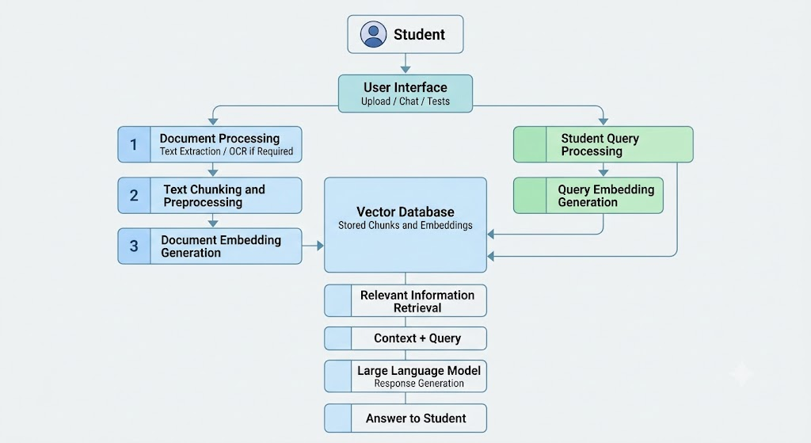
System Architecture Figure 1

Data Flow
The data flow describes how information moves through the system from document submission to response generation.
Input: The student uploads academic documents or submits a question through the user interface.
Processing: Uploaded documents are processed using appropriate text-extraction tools. The extracted text is divided into chunks and converted into embeddings.
Storage: The document chunks and their vector representations are stored in the vector database for subsequent retrieval.
Retrieval: When a question is submitted, the system searches the stored embeddings to identify content relevant to the query.
Generation: The retrieved information is supplied to the language model along with the question to generate a context-based answer.
Output: The generated answer is displayed to the student through the interface.
The overall data flow can be represented as:
Document Input → Text Extraction → Preprocessing → Chunking → Embedding Generation → Vector Storage → Query Processing → Retrieval → Language Generation → Answer Output
If diagnostic assessments are included, the assessment answers form an additional input. The system can evaluate the responses, analyse the results, and present performance information to help guide revision.
3.4 Hardware Requirements
Minimum Hardware Configuration
Component | Specification
Processor | Intel Core i5 / AMD Ryzen 5 or higher
RAM | 8 GB
Storage | 64GB SSD or Higher
GPU | Optional; CPU-based execution is possible with suitable models
Network | Stable internet connection for downloading models and software dependencies

Recommended Hardware Configuration (Deployment/Multi-Stream Server):
Component | Specification
Processor | Intel Core i7 / AMD Ryzen 7 or higher
RAM | 16–32 GB
Storage | 512GB SSD or Higher
GPU | NVIDIA GPU with 6–8 GB VRAM or more, depending on model requirements
Network | Stable internet connection for downloading models and software dependencies

Hardware Justification:
- Processor: A modern multi-core processor helps with document processing, text extraction, embedding generation, and application execution.
- RAM: Adequate memory is required to run the application, process documents, maintain the vector database, and execute the language model. Larger local models may require considerably more memory.
- Storage: SSD storage provides faster access to application files, uploaded documents, model files, and vector database data.
- GPU: A compatible GPU can accelerate model inference and other supported computations. However, a GPU is not mandatory if the selected models support CPU execution.
- Network: Internet access may be required to install dependencies and download language or embedding models. Once the necessary components are available locally, supported workflows may operate without a continuous internet connection.
The recommended configuration provides a more comfortable development environment, particularly when running language models locally through Ollama.

3.5 Software Requirements
Software Tools
Software | Description
Operating System | Windows 10/11 or a compatible Linux distribution
Programming Language | Python 3.10 or a compatible version supported by the dependencies
Frontend Technologies | HTML5, CSS3, and JavaScript
Development Environment | Visual Studio Code or any applicable enviroment
Language Model Runtime | Stable internet connection for downloading models and software dependencies

Core Libraries & Framework
Library / Framework | Purpose
LangChain | Supports the integration of document processing, retrieval, and language-model components
Hugging Face Embedding Models | Converts text into vector representations for semantic search
ChromaDB | Stores document embeddings and associated information for similarity-based retrieval
PyPDFLoader | Extracts text from PDF documents
DOCX Loader | Loads text from Word documents
PPTX Loader | Extracts text from PowerPoint presentations
EasyOCR | Supports text extraction from images, if integrated into the application
Python Standard Libraries | Support general application logic, file handling, and data processing

Software Modules
The system is organised into functional modules that handle document processing, information retrieval, response generation, and the user interface.
- Document Upload Module
  - Accepts educational materials in supported file formats.
  - Organises uploaded documents for processing.
  - Handles file selection and validation.
- Text Extraction and Preprocessing Module
  - Extracts text from supported documents.
  - Cleans and prepares extracted content.
  - Divides the text into smaller chunks for efficient retrieval.
- Embedding Generation Module
  - Converts document chunks into semantic embeddings.
  - Generates vector representations of student queries.
  - Prepares data for similarity-based retrieval.
- Vector Database Module
  - Stores document embeddings and associated text.
  - Maintains indexed information for retrieval.
  - Supports searching for content relevant to a query.
- Retrieval-Augmented Generation Module
  - Retrieves relevant document chunks for a student's question.
  - Combines retrieved information with the original query.
  - Supplies the resulting context to the language model.
- Language Model Module
  - Integrates with the selected language model through Ollama.
  - Generates responses using the retrieved context.
  - Returns the generated answer to the application.
- User Interface Module
  - Provides the interface for uploading documents and asking questions.
  - Displays generated answers.
  - Supports navigation between available application functions.

- Subject Management Module
  - Organises educational materials by subject, if implemented.
  - Helps users access subject-specific learning resources.
- Diagnostic Assessment and Performance Analysis Module
  - Supports topic-based assessments, where implemented.
  - Analyses assessment results to identify topics that may need additional revision.
  - Can provide performance summaries to support targeted learning.

CHAPTER 4. IMPLEMENTATION

4.1 METHODOLOGY
The AI-Powered Personalized Learning System follows a modular methodology that combines document processing, semantic information retrieval, and AI-based response generation. The system processes educational materials, stores their semantic representations, and retrieves relevant information to answer student queries.
The main stages of the methodology are:
- Document Collection: Educational materials are uploaded in supported formats.
- Text Extraction: Text is extracted from the uploaded documents using suitable processing tools.
- Text Preprocessing: The extracted content is cleaned and divided into smaller chunks.
- Embedding Generation: Each text chunk is converted into a numerical vector representation.
- Vector Storage: The embeddings and associated text are stored in a vector database.
- Information Retrieval: Relevant chunks are retrieved based on the student's query.
- Response Generation: The retrieved content is passed to a Large Language Model to generate a context-based answer.
- Result Presentation: The generated response is displayed through the user interface.
This methodology enables the system to connect educational resources with natural-language question answering.

Research Approach
The project follows an applied development approach focused on designing and implementing an AI-based educational assistance system. It combines document processing techniques, semantic search, and language generation to address challenges associated with accessing and understanding academic materials.
The development approach involves studying existing RAG techniques, selecting suitable software components, designing the system architecture, implementing the main modules, and evaluating their operation through functional testing.
The effectiveness of the system depends on the quality of the uploaded documents, the relevance of retrieved content, and the language model's ability to generate accurate responses.

System Development Methodology
The system is developed using an iterative approach in which individual components are implemented and tested before being integrated into the complete application.
The development process consists of the following stages:
- Requirement Analysis: Identifying the system's intended functions, including document uploading, question answering, and learning support.
- System Design: Defining the architecture, data flow, software components, and interactions between modules.
- Module Development: Implementing document processing, embedding generation, retrieval, response generation, and user interface components.
- Module Testing: Checking individual components to identify errors and verify expected behaviour.
- System Integration: Connecting the modules to establish the complete question-answering workflow.
- Validation: Testing the integrated application with representative documents and queries.
This iterative approach allows errors to be identified and corrected throughout development.

Data Collection and Preprocessing

The system uses educational documents supplied by the user as its primary information source. These materials may include lecture notes, study guides, textbooks, and presentations in supported file formats. The uploaded documents provide the reference content used by the retrieval component when answering student questions. The system's responses therefore depend partly on the relevance and completeness of the available materials.

Text Extraction
After a document is uploaded, the system uses an appropriate loader or extraction tool to obtain its textual content. Different file formats may require different processing methods.
For example, PDF, Word, and PowerPoint documents can be processed using compatible document loaders. If image-based documents are supported, an Optical Character Recognition (OCR) tool such as EasyOCR can be used to extract text from images.

Text Preprocessing and Chunking
The extracted text is prepared for semantic retrieval. Preprocessing may include removing unnecessary content, normalising text where appropriate, and dividing the content into smaller chunks.
Chunking allows the system to retrieve relevant sections instead of supplying an entire document to the language model. The chunk size and overlap can affect retrieval quality and should be selected according to the nature of the educational material.

Embedding Generation & Storage
An embedding model converts each text chunk into a numerical vector representing its semantic meaning. The resulting vectors, together with the corresponding text and associated metadata, are stored in a vector database such as ChromaDB.
When a student submits a question, the system uses semantic similarity to locate document chunks relevant to the query. These retrieved chunks provide contextual information for generating the answer.

System Integration
System integration involves connecting the document-processing pipeline, embedding model, vector database, retrieval component, language model, and user interface.
The document-processing component prepares the source material, while the embedding component generates vector representations. The vector database stores the indexed information, and the retrieval component searches for relevant content when a query is submitted.
The retrieved content is then passed to the language model, which generates a response for display in the user interface.

Testing and Validation
The final, integrated system (using Model 2) undergoes
several testing stages:

- Unit Testing: Checks individual functions, such as text extraction, preprocessing, and query handling.
- Integration Testing: Verifies communication between document loaders, embedding models, the vector database, and the language model.
- Functional Testing: Checks whether users can upload supported documents, submit queries, and receive responses.
- Retrieval Testing: Examines whether the system retrieves content relevant to a submitted question.
- Response Validation: Checks whether generated answers are supported by the retrieved material and are relevant to the question.
- Error Handling Testing: Tests how the application responds to unsupported files, empty documents, invalid queries, or unavailable model services.

Ethical and Privacy Considerations

The AI Study Assistant processes educational materials and student queries, so privacy, responsible use, and information reliability should be considered.
- Data Privacy: Uploaded documents and student queries should be handled carefully, particularly when they contain personal or confidential information.
- Local Processing: Running the language model locally may reduce the need to send queries to an external AI service, depending on the system configuration.
- Answer Reliability: AI-generated responses may contain errors. Students should verify important information against their original study materials.
- Document Permissions: Users should upload materials they are permitted to use.
- Responsible Learning: The system should support learning and revision rather than encourage uncritical dependence on generated answers.
- Secure Storage: Uploaded files, vector database data, and assessment results should be stored and accessed appropriately.

4.2 Implementation
The system implementation is organised into modules, with each module responsible for a specific stage of the learning workflow.
Document Upload Module:
This module allows users to select and upload educational materials in supported formats. It validates the selected files and passes them to the appropriate document-processing component.
Document Processing Module:
This module extracts textual content from uploaded documents. Depending on the supported formats, it uses document loaders and may incorporate OCR for extracting text from images.
The extracted content is prepared for further processing through cleaning and chunking.

Embedding Generation Module:
This module converts document chunks into vector representations using a compatible embedding model. The same embedding model or a compatible configuration is used to represent student queries so that semantic similarity can be calculated.
Vector Database Module:
This module stores the generated embeddings alongside the corresponding text and metadata. During question answering, it enables the retrieval component to search for relevant document chunks.
RAG-Based Question Answering Module:
This is the central component of the system. When a student submits a question, the module retrieves relevant content from the vector database and combines it with the query.
The resulting context is supplied to the Large Language Model, which generates a response based on the retrieved information. This process aims to make answers more relevant to the student's uploaded academic materials.
Language Model Integration Module:
This module connects the application to the selected Large Language Model. When Ollama is used, it manages requests to the configured local model and returns generated responses to the application.
The model's output depends on the selected model, the supplied context, and the structure of the prompt.
User Interface Module:
The user interface provides access to the application's main functions. It enables users to interact with available features, submit questions, and view generated answers.
The interface communicates with the backend to initiate document processing and question-answering operations.
Diagnostic Assessment and Performance Analysis Module:
If implemented, this module supports diagnostic tests and analysis of student responses. Assessment results can be used to identify topics that may require additional revision.
This module complements the question-answering workflow by supporting the identification of learning gaps. Its functionality should be described according to the assessment and analysis features available in the final application.

Integration Summary
The implementation combines document processing, semantic embeddings, vector storage, information retrieval, and language generation into a unified workflow.
Initially, educational materials are processed and indexed in the vector database. When a student submits a question, the retrieval component searches the stored information and supplies relevant content to the language model. The generated response is then returned through the user interface.
The modular design allows individual components to be maintained and improved independently. Additional features, such as diagnostic assessments, performance analysis, and personalised learning recommendations, can be integrated where supported by the implementation.
Overall, the system demonstrates how Retrieval-Augmented Generation can be applied to educational materials to provide context-based academic assistance.

CHAPTER 5. CONCLUSION AND FUTURE WORK

5.1 CONCLUSION
The AI-Powered Personalized Learning System demonstrates the application of Artificial Intelligence (AI) and Retrieval-Augmented Generation (RAG) in educational assistance. By combining document processing, semantic embeddings, vector-based retrieval, and Large Language Model (LLM) integration, the system is designed to provide context-based answers using students' academic materials.
The proposed approach helps simplify access to educational information and supports self-paced learning. The modular architecture also provides a foundation for incorporating additional educational features. Although the system has potential to improve the learning experience, its effectiveness depends on document quality, retrieval relevance, and the reliability of generated responses.

Purpose and Achievements
The primary purpose of the project is to develop an AI-based learning assistant that enables students to interact with their academic materials through natural-language questions.
The main objectives and intended achievements include:
- Developing a system architecture that integrates document processing and AI-based question answering.
- Using text extraction and preprocessing to prepare educational materials for retrieval.
- Applying semantic embeddings to represent document content.
- Using a vector database to store and retrieve relevant information.
- Integrating a Large Language Model to generate responses based on retrieved context.
- Establishing a foundation for diagnostic assessment and personalised learning support.
The extent to which each objective has been achieved should be confirmed against the final implementation and its test results.

Significance of the System
The significance of the proposed system lies in its application of RAG to educational resources. Instead of relying exclusively on a language model's general knowledge, the system retrieves relevant information from available study materials and uses it as context for generating responses.
This approach can help students locate relevant information more efficiently and clarify academic doubts. It also demonstrates how document processing, semantic search, and language generation can be combined to develop practical AI-based educational applications.
Furthermore, the modular design allows the system to be extended with additional learning-support features as the project develops.

Evaluation and Results
The system should be evaluated to determine whether its components function correctly and whether its responses are useful for students. The following criteria can be used:
- Document Processing: Verify whether supported documents are uploaded and their text is extracted correctly.
- Retrieval Performance: Check whether the system retrieves relevant sections for different academic questions.
- Answer Relevance: Assess whether generated responses address the questions asked.
- Contextual Accuracy: Compare generated answers with the source documents to identify unsupported or incorrect information.
- System Functionality: Verify that the user interface, vector database, and language model work together correctly.
- Response Time: Measure the time required to retrieve information and generate answers.
The evaluation findings should be recorded using actual test cases and observations. Quantitative metrics, such as retrieval precision or response time, may be included if they have been measured.
As no verified experimental results are available in this report, numerical accuracy scores or claims of improved learning outcomes are not presented.

Challenges Faced
During implementation, the challenges we incurred in each module were:

- Document Processing: Different file formats may require different extraction methods, and scanned documents can introduce OCR errors.
- Text Chunking: Selecting suitable chunk sizes is important because chunks that are too small may lose context, while chunks that are too large may reduce retrieval efficiency.
- Embedding Generation: The selected embedding model must represent document content and student queries effectively.
- Retrieval Relevance: The system may retrieve information that is related to, but does not fully answer, a question.
- Language Model Reliability: Generated responses may contain inaccuracies or information not supported by the retrieved context.
- Local Model Execution: Running language models locally requires sufficient memory and processing resources, and performance varies according to the model and hardware.
- Module Integration: Connecting document loaders, embeddings, the vector database, and the language model requires compatible configurations and reliable data flow.

Limitations
Despite its potential, the proposed system has several limitations:
- The quality of responses depends on the completeness and accuracy of uploaded educational materials.
- Retrieval may fail to identify the most relevant content for ambiguous or complex questions.
- Language models may generate incorrect or unsupported information.
- OCR-based extraction may introduce errors when documents contain poor-quality images or complex layouts.
- Local language-model performance depends on available hardware and the selected model.
- Personalised learning recommendations are limited by the assessment data and analysis capabilities available in the implementation.
- The system's effectiveness as a learning tool requires further evaluation with representative academic questions and users.
These limitations should be considered when interpreting the system's responses and evaluating its suitability for educational use.

5.2 FUTURE WORK
Several enhancements could improve the functionality and effectiveness of the AI Study Assistant:
- Improved Retrieval: Introduce advanced retrieval techniques, reranking, and query reformulation to improve the relevance of retrieved information.
- Enhanced Document Support: Improve the processing of scanned PDFs, images, tables, and other complex document structures.
- Automated Assessment Generation: Generate quizzes and practice questions from uploaded study materials.
- Personalised Learning: Use assessment results to identify weak topics and recommend relevant study resources.
- Performance Dashboard: Provide topic-wise progress summaries and visual representations of assessment results.
- Answer Verification: Include source references or document excerpts so students can verify generated responses.
- Multilingual Support: Extend the system to support questions and educational materials in multiple languages.
- Performance Optimisation: Improve processing speed, memory usage, and local model execution.
- Expanded Evaluation: Conduct systematic testing with a wider range of documents and questions to assess retrieval quality, answer reliability, and usability.
These enhancements could help transform the current system into a more comprehensive learning platform that combines academic question answering with assessment and personalised revision support.
In conclusion, the AI Study Assistant provides a foundation for applying RAG and language models to educational materials. With further development, testing, and validation, it has the potential to become a more reliable and useful tool for supporting students' independent learning.

Sample Source Code
The source code comprises of 4 separate parts.
- Main (Backend and Application Integration)
- RAG (Retrieval – Augmented Generation)
- App (Frontend Functionality)
- Style (User Interface Styling)
- import os
import json
import shutil
import hashlib
import threading
from datetime import datetime
from urllib.parse import quote_plus
import torch
import easyocr
import ollama
from langchain_core.documents import Document
from langchain_community.document_loaders import (
PyPDFLoader,
Docx2txtLoader,
UnstructuredPowerPointLoader,
)
from langchain_text_splitters import (
RecursiveCharacterTextSplitter
)
from langchain_huggingface import (
HuggingFaceEmbeddings
)
from langchain_community.vectorstores import (
Chroma
)
class RAGBackend:
# =====================================================
# INITIALIZATION
# =====================================================
def __init__(self):
self.base_dir = os.path.dirname(
os.path.abspath(__file__)
)
self.rag_root = os.path.join(
self.base_dir,
"rag_data"
)
os.makedirs(
self.rag_root,
exist_ok=True
)
self.subject_data = {}
self.current_subject = None
self.reader = None
self.embeddings = None
self.current_device = None
self.lock = threading.Lock()
self.status = {
"state": "idle",
"message": "Ready",
"progress": 0
}
- def _safe_name(self, subject):
value = "".join(
c
if c.isalnum() or c in " -_"
else "_"
for c in str(subject)
)
value = "_".join(
value.strip().split()
)
return value or "Subject"
def _subject_dir(self, subject):
return os.path.join(
self.rag_root,
self._safe_name(subject)
)
def _documents_dir(self, subject):
return os.path.join(
self._subject_dir(subject),
"documents"
)
def _chroma_dir(self, subject):
return os.path.join(
self._subject_dir(subject),
"chroma"
)
def _tests_file(self, subject):
return os.path.join(
self._subject_dir(subject),
"tests.json"
)
def _metadata_file(self, subject):
return os.path.join(
self._subject_dir(subject),
"subject.json"
)

Sample Input & Output :

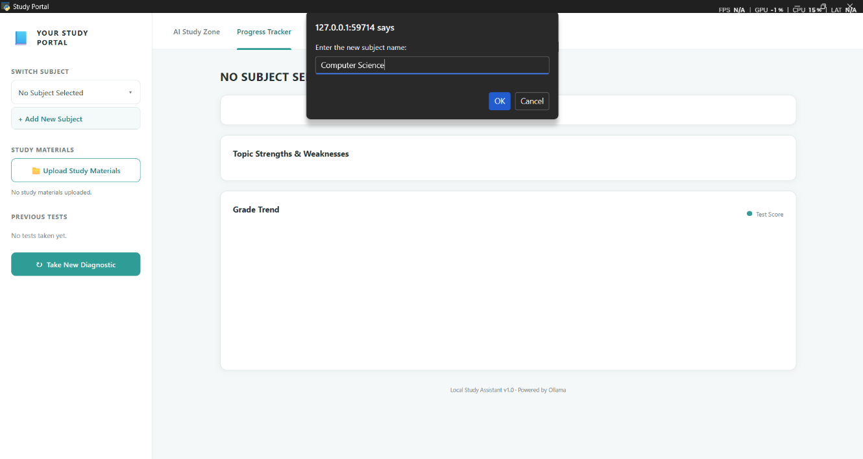

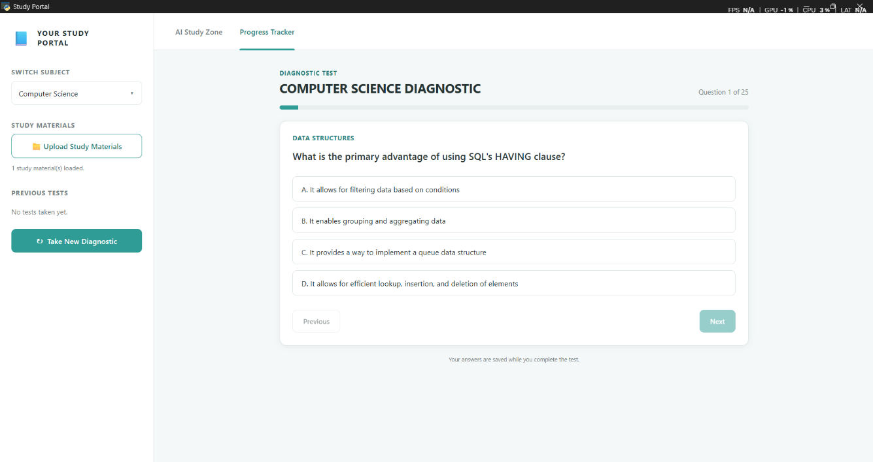

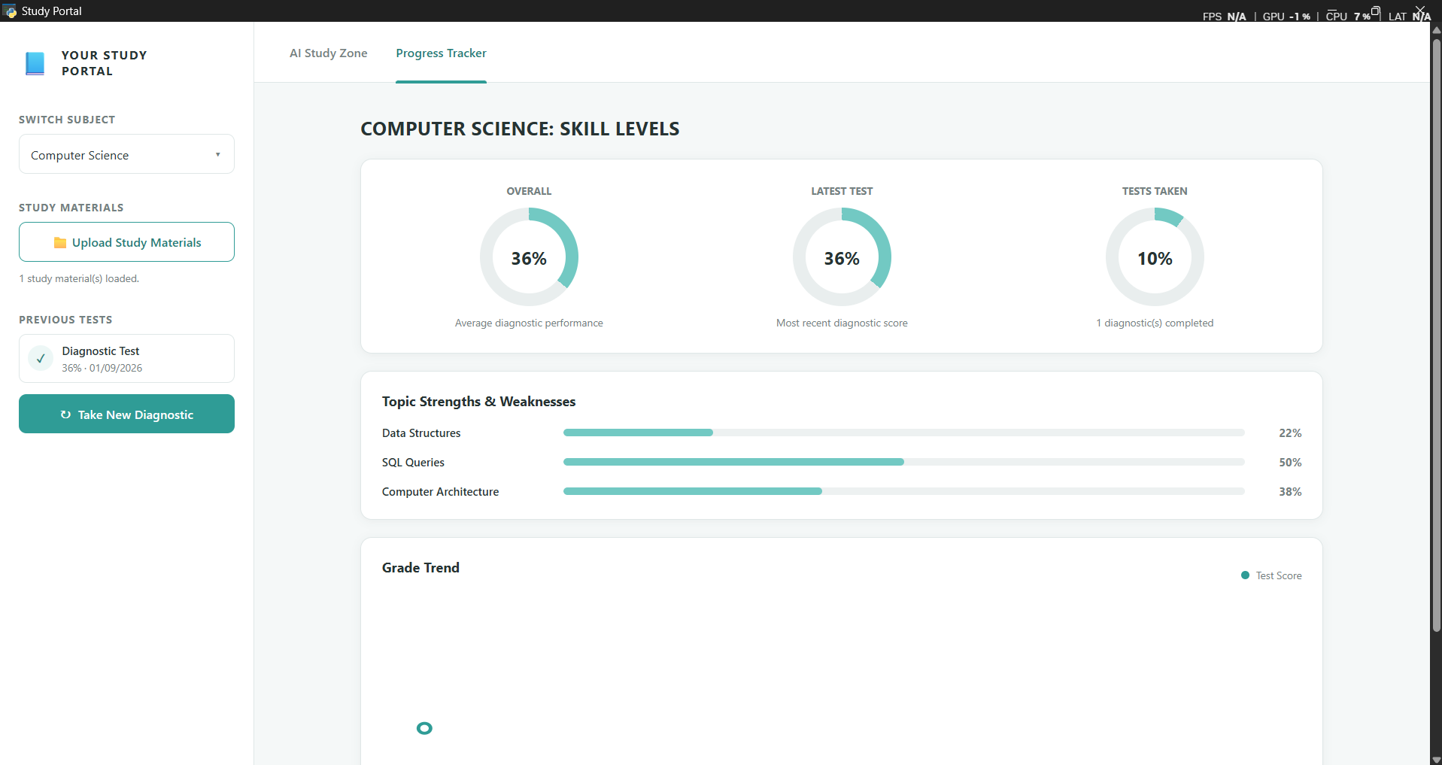

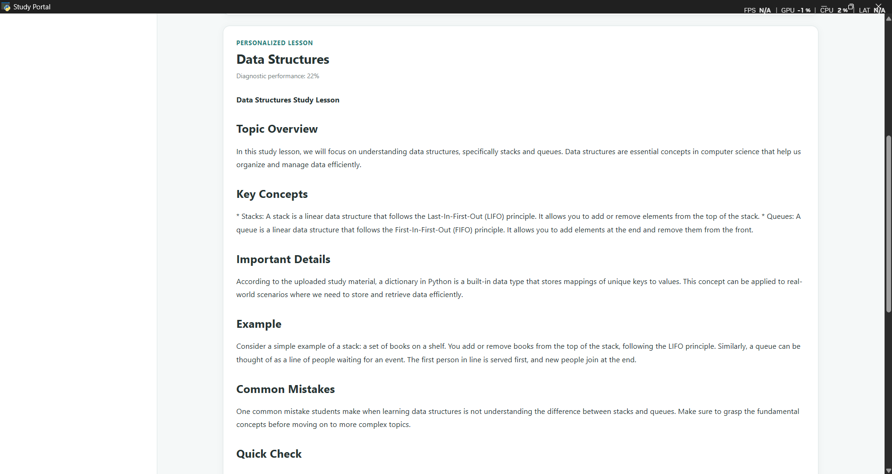

- References:
Lewis, P., Perez, E., Piktus, A., et al. (2020). Retrieval-Augmented Generation for Knowledge-Intensive NLP Tasks. Advances in Neural Information Processing Systems (NeurIPS), 33.
- Li, Z., Wang, Z., Wang, W., Hung, K., Xie, H., & Wang, F. L. (2025). Retrieval-Augmented Generation for Educational Application: A Systematic Survey. Computers and Education: Artificial Intelligence, 8, 100417.
- Swacha, J., & Gracel, M. (2025). Retrieval-Augmented Generation (RAG) Chatbots for Education: A Survey of Applications. Applied Sciences, 15(8), 4234.
- OpenRAG: Open-source Retrieval-Augmented Generation Architecture for Personalized Learning. (2024). Proceedings of the 2024 International Conference on Artificial Intelligence, Robotics, and Communication (ICAIRC).
- Gao, Y., Xiong, Y., Gao, X., et al. (2024). Retrieval-Augmented Generation for Large Language Models: A Survey. arXiv:2312.10997.

CERTIFICATION
The abstract of this project was submitted to the Capital House Conference, Turkey, for consideration. The email correspondence confirming the acceptance of the submission is included below as supporting evidence.



